St Marys Roman Catholic Primary School
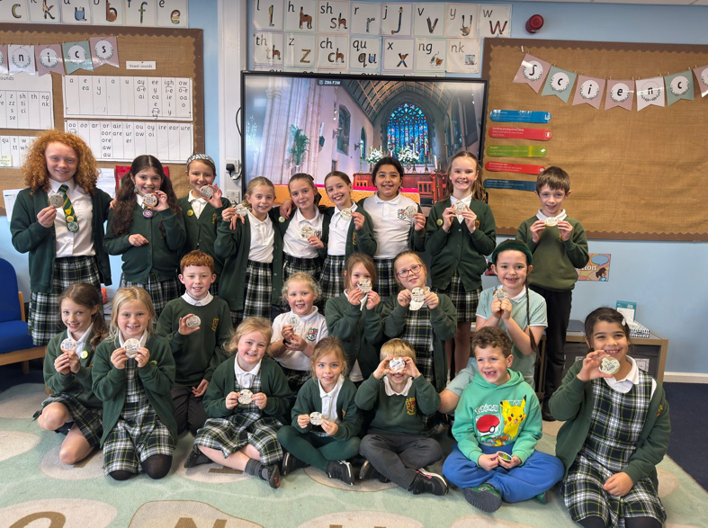
Annual Plan of Provision 2025 – 2026

‘Our School, Our Family, Modelled on Christ.’
- Love- We try to be like Jesus and always keep him in our hearts
- Kindness- We live our mission by showing kindness through our relationship with God, caring for one another, and respecting all of creation
- Courage- We stand up for what is right , even when it is difficult
- Humility- We understand that we are all different but we respect each other
- Peace- We treasure and look after our world so that we may share it together in peace with Jesus

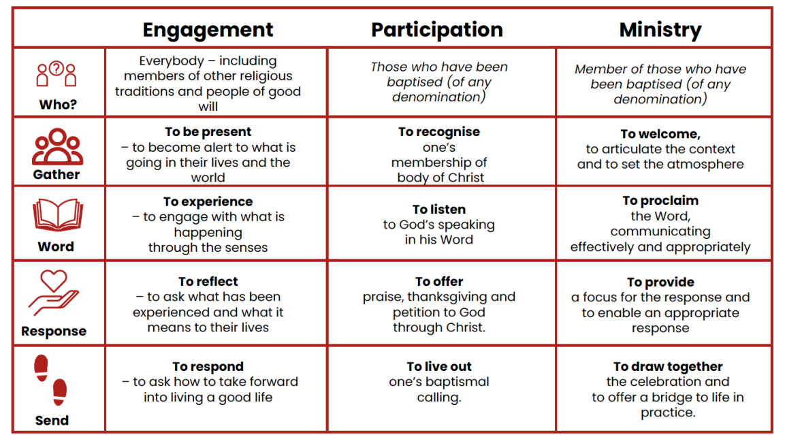
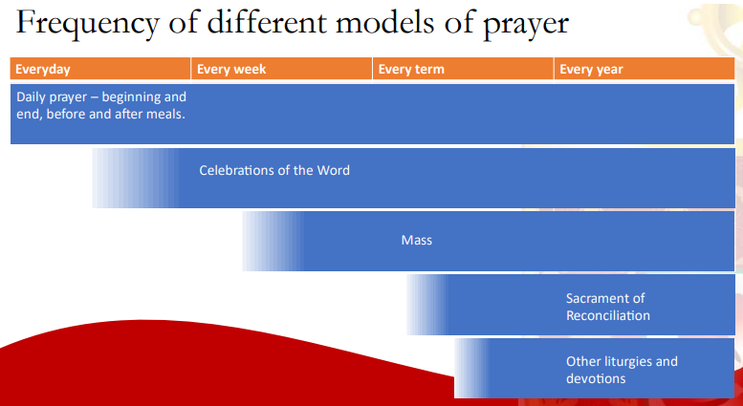
MENU OF PROVISION
1. Prayer, Celebrations of the Word and Liturgy timetable
2. Liturgy of Mass
3. Class Saints and Feast days
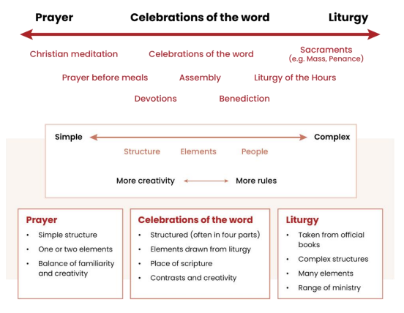
4. Liturgical Events & Rolling Worship
5. Hymnody
6. School Ordo 2025-2026
7. Prayer Progression
8. S2: Year group adaptations
9. S3: Pupil Ministry

Prayer, Celebrations of the Word and Liturgy Timetable
Day | Event | Location
Monday | Whole School Assembly/Celebration of the Word – Led by Head teacher  Traditional daily prayers in class | Hall  Classrooms
Tuesday | Class Celebration of the Word led by Class teacher  Traditional daily prayers in class | Hall  Classrooms
Wednesday | Traditional daily prayers in class | Classrooms
Thursday | Whole School Music Liturgy  Teacher/child planning for Fridays Class COW  Traditional daily prayers in class | Hall  Classrooms
Friday | Child led (planning & evaluation) Celebration of the Word  REACH with opening prayers  Traditional Prayers in class  Adult/Child evaluations:  GF – Key Stage 2, LP – Year 2 | Hall  Classrooms

Liturgy of the Mass
Term | Date/Time | Celebrated with
Autumn Term

Spring Term | W/C 9th March 2026 | Whole School  Father Broadley
Summer Term | W/C 15th June 2026 | Whole School  Father Broadley

Class Saints and Feast Days
Class | Saint | Feast day
Class 1 | Saint Bernadette | 16th April
Class 2 | Saint Patrick | 17th March
Class 3 | Saint Carlos Acutis | 12th October
Class 4 | Saint Francis of Assisi | 4th October
Class 5 | Saint Teresa of Calcutta | 5th September

Liturgical Events & Rolling Worship
Term | Date | Focus
Autumn 1 | Tuesday 23rd September  Wednesday 24th September  Wednesday 1st October – Friday 24th October  Wednesday 1st October  Monday 20th October | Jubilee Prayer Stations  Jubilee Pledge Day  Daily Rosary for the month of October (lunchtimes)  Laudato Si Team - Fairtrade  Caritas Ambassadors – Operation Christmas Child
Autumn 2 | Monday 3rd – Monday 10th November  Tuesday 11th November  Thursday 13th November  Wednesday 19th November 3pm  Friday 21st November  Sunday 23rd November 2025  Friday 5th December  Friday 19Th December | Poppies  Remembrance Assembly  Jubilee Anchor Celebration of the Word  EYFS Stay & Pray  Jubilee Celebration Day  Feast of Christ the King  Year 1 Stay & Pray  Year 2 Stay & Pray  Class 3 Stay & Pray  Class 4 Stay & Pray  Class 5 Stay & Pray  Singing in the community - Tesco  EYFS & KS 1 Nativity  Christmas Carol Service - Church
Spring 1 | Sunday 18th – Sunday 25th January  Dates TBC | Christian Unity Week  EYFS Stay & Pray  Year 1 Stay & Pray  Year 2 Stay & Pray  Class 3 Stay & Pray  Class 4 Stay & Pray  Class 5 Stay & Pray
Spring 2 | Monday 23rd February – Thursday 2nd April 2026  Monday 23rd February – Thursday 2nd April 2026  Friday 13th March 2026  W/C 30th March 2026  W/C 30th March 2026  Dates TBC  18th February 2026?? | Messy Lent – KS1/GIFT Team  Food Bank Fridays  St Joseph’s Penny  CAFOD Family Fast Day  Big Lent Walk to the Halo  Stations of the Cross Prayer Stations  EYFS Stay & Pray  Year 1 Stay & Pray  Year 2 Stay & Pray  Class 3 Stay & Pray  Class 4 Stay & Pray  Class 5 Stay & Pray  Ash Wednesday ashes
Summer 1 | Monday 18th May 2026  1st May – 31st May 2026 | Crowning of Our Lady  Praying the Month of the Rosary  EYFS Stay & Pray  Year 1 Stay & Pray  Year 2 Stay & Pray  Class 3 Stay & Pray  Class 4 Stay & Pray  Class 5 Stay & Pray
Summer 2 | Monday 15th – Friday 19th June 2026 | Refugee Week  EYFS Stay & Pray  Year 1 Stay & Pray  Year 2 Stay & Pray  Class 3 Stay & Pray  Class 4 Stay & Pray  Class 5 Stay & Pray

Prayer Progression
The table below indicates the year group in which specific prayers will be introduced over the year.
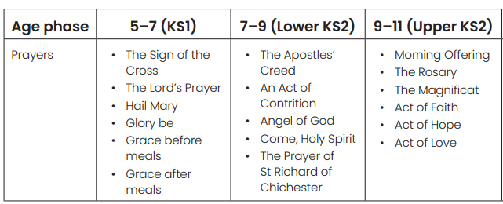

Plan of Provision for Prayer
Term | Class | What | When
Autumn 1 | Classes 1 - 5 | The Rosary | Throughout October
Autumn 2 | All Classes  Class 3  Classes 4 & 5 | Morning Offering  Apostles Creed  The Magnificat | Start of day  Start of RE lesson  Start of RE lesson
Spring 1 | All Classes  Classes 4 & 5  Whole School | Morning Offering  Apostles Creed  The Act of Love | Start of day  Start of RE lesson  Mission Statement Assembly
Spring 2 | Classes 3, 4 & 5  All classes  Classes 3, 4 & 5 | Angel of God  Act of Contrition  St Richard of Chichester | Start of day  Monday COW (throughout Lent)  End of day (throughout Lent)
Summer 1 | Classes 3, 4 & 5  Classes 1 – 5  Classes 4 & 4 | Come Holy Spirit  The Rosary  Acts of Faith, Hope & Love | During Pentecost  Throughout May  Class COW
Summer 2 | Classes 4 & 5 | Acts of Faith, Hope & Love | Class COW

EYFS
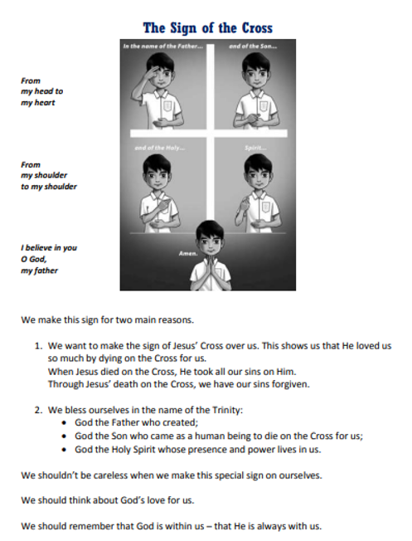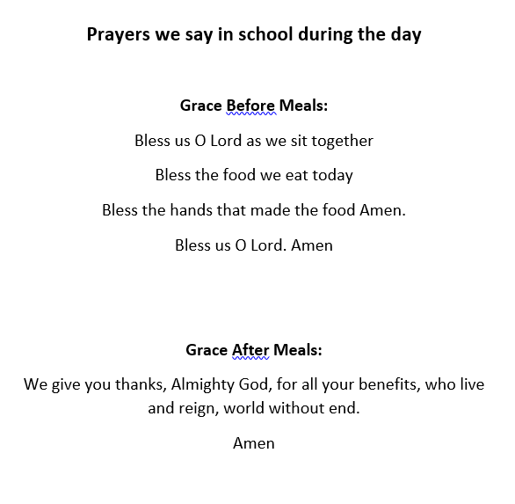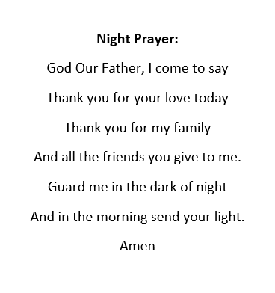

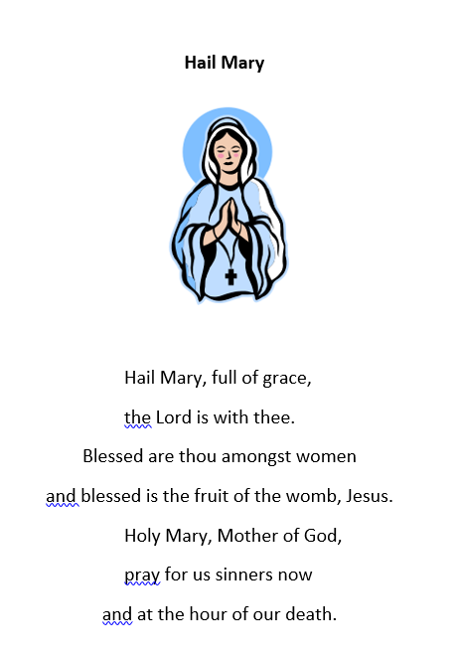
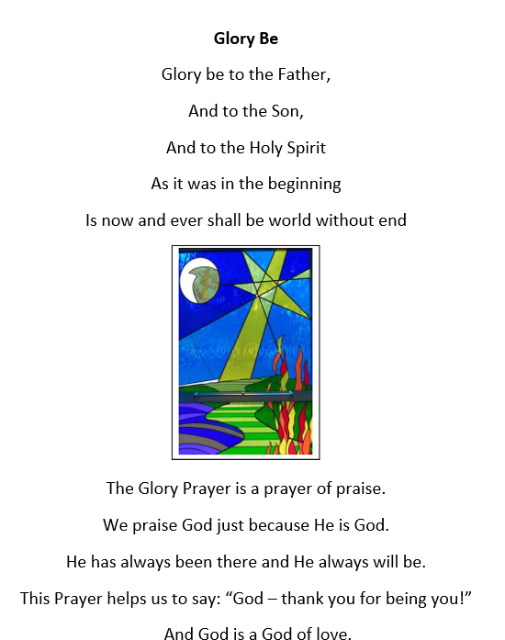
KEY STAGE 1
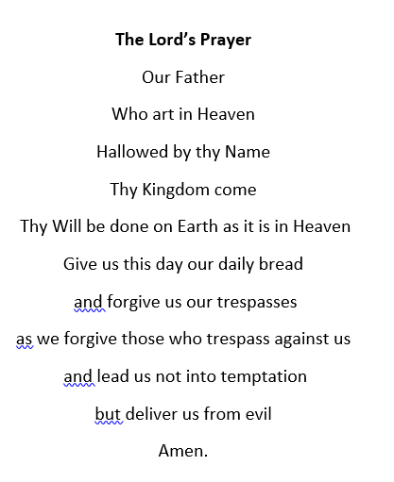

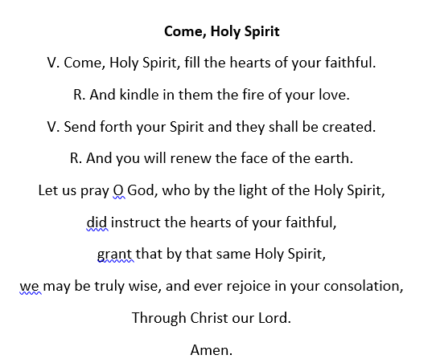
LOWER KEY STAGE 2
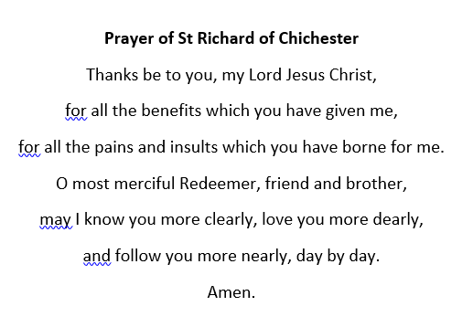
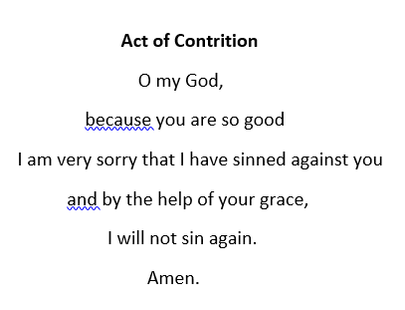
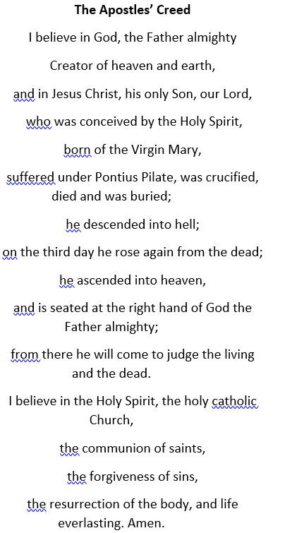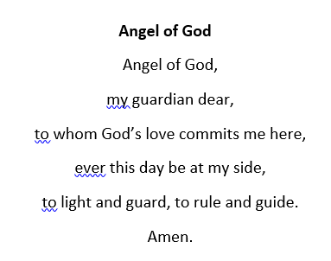

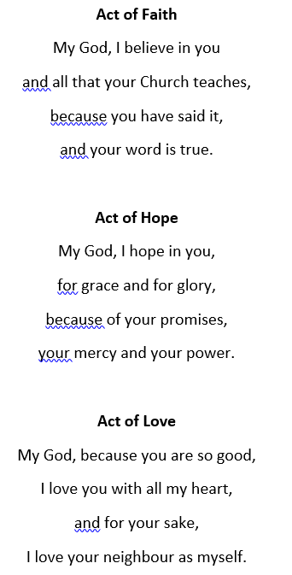
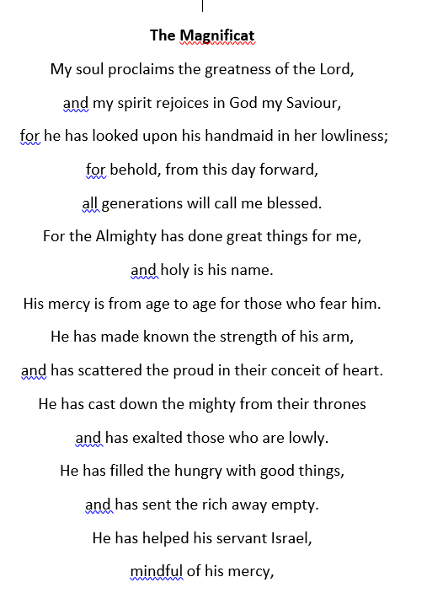
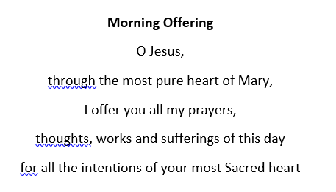
UPPER KEY STAGE 2



HYMNODY
Hymnody – Entry/Exit songs by term. (All themes linked to Gospel reading from Sunday before – based on resources from The Mark 10 Mission and Salford Diocese)
Term | Hymns
Autumn 1 | Here I am Lord  As I kneel before you  Sign your Cross  Shine Jesus Shine  Make me a channel of your Peace  Bread of Life
Autumn 2 | Be Still for the Presence of The Lord (Nov)  Servant King (Nov)  Advent: Our God Reigns, O Come O Come Emmanuel  Mary, Did You Know  Shout to The Lord  Carols: Away in a Manger, Silent Night, Ding Dong Merrily on High, Hark the Herald Angels sing, O Come all ye Faithful, Once in Royal David’s City
Spring 1 | Epiphany: We Three Kings  Christ be our light  Follow me, Follow me (Feb)  Here I am to worship  Sign your Cross
Spring 2 | Sing Hosanna  King of Kings (Mar/Apr)  This is my body (Mar/Apr)  Once Again  Servant King (Mar/Apr)  Be Still for the presence of The Lord (Mar/Apr)
Summer 1 | As I Kneel Before You (The month of the Rosary)  Christ is Risen  What a Beautiful Name  The Lord is my Shepherd  Do not be afraid
Summer 2 | Lord, I lift your name on High  Shout to The Lord  Our God Reigns  I watch the sunrise  Lord Jesus Christ (Living Lord)


School Ordo 2025-2026
Week beginning  and theme | Sunday Gospel/  Liturgical Year | Feast days | Events | Resources
31st August  CREATION | Luke 14:1. 7-14  ‘Everyone who exalts himself will be humbled, and he who humbles himself will be exalted.’ | (3rd) St Gregory the Great | Season of Creation  (1st Sept – 4th Oct)  (1st) World Day of Prayer for the Care of Creation | Season of Creation  Schools - Laudato Si’ Centre (laudatosicentre.org.uk)  Creation Care: The God Who Speaks
7th September  COMMUNITY | Luke 14:25-33  ‘Anyone who does not renounce all that he has cannot be my disciple.’ | (8th) The Birthday of the Blessed Virgin Mary | Caritas Harvest Shopping list | www.caritassalford.org.uk
14th September  EDUCATION | John 3:13-17  ‘The Son of Man must be lifted up.’ | (14th) The Exaltation of the Holy Cross  (17th) St Hildegard of Bingham, patron saint of ecology | (14^{th)} Education Sunday | Catholic Bishops Conference: Education Sunday  Education Sunday 2025 Churches Together
21st September  SERVICE | Luke 16:1-13  ‘You cannot serve God and money.’ | (21st) St Matthew  (24th ) Our Lady of Walsingham  (27^{th)} St Vincent de Paul | (21st) UN International Day of Peace  (22nd- 28th) Recycle week  22nd -5th Oct) Fairtrade Fortnight | Evangelii Gaudium Sunday - Catholic Bishops' Conference (cbcew.org.uk)  Recycle Week campaign | Recycle Now  Peace one Day  Fairtrade Fortnight - Fairtrade
28th September  GRATITUDE | Luke 16:19-31  ‘You received good things, and Lazarus bad things; now he is comforted here, and you are in anguish.’ | (29th) Saints Michael, Gabriel and Raphael  (2nd) The Holy Guardian Angels  (4th) St Francis of Assisi, patron saint of environment, animals and birds | (28th) Harvest Thanksgiving  (29th) World Day of Migrants & Refugees  (1st) World Vegetarian Day  (1st-31st) Black History month  (3rd) Cafod Harvest Fast | For Caritas prayer resource for Migrants and Refugees www.caritassalford.org.uk  Family Fast Day (cafod.org.uk)  Bishops Conference World Day of Migrants and Refugees  What You Can Do - World Vegetarian Day
5th October  TRUST | Luke 17:5-10  ‘If you had faith.’ | (7th) Our Lady of the Rosary | (6th -12th) Challenge Poverty Week  (10th) UN World Mental Health Day  (10th) World Homeless Day  October – month of the Rosary | Caritas prayer resources and call to action at www.caritassalford.org.uk  prayer resources and Big Sleep Out information at www.caritassalford.org.uk  World Federation for Mental Health  Westminster Diocese Rosary Resources
12th October  THANKSGIVING | Luke 17:11-19  ‘No one was found to return and give praise to God except this foreigner.’ | (12th) St Carlo Acutis  (15th) St Teresa of Avila  (18th) St Luke | (12th – 18th) Prisons Week  (17th) UN International Day for the Eradication of Poverty | St Carlo Acutis resources at dioceseofsalford.org.uk/youth/  PACT (Catholic Prisoners’ Aid Society): Prisoners Sunday  Prisons Week
19th October  MISSION | Luke 18:1-8  ‘God will give justice to his elect, who cry to him. |  | (19th) World Mission | World Mission Sunday - Catholic Bishops' Conference)  What is World Mission Sunday? - Missio
26th October  HUMILITY | Luke 18:9-14  ‘The tax collector went down to his house justified, rather than the Pharisee.’ | (27th) Ss Simon and Jude | Caritas’ Annual Celebration of Human Dignity.  Anniversary of Nostra Aetate | Caritas Mass information www.caritassalford.org.uk
2nd November  REJOICE | Matthew 5:1-12a  ‘Rejoice and be glad, for your reward is great in heaven.’ | (1st )All Saints (celebrated on Sunday)  (2nd) All Souls  (4th) St Charles Borromeo | Visit of the Relics of St Carlo Acutis details tbc | Relic Visit information  All Saints Celebration of the Word: Cafod  All Saints Day Prayers: Hallow  The God Who Speaks: All Saints and All Souls
9th November  REMEMBRANCE | John 2:13-22  ‘He was speaking about the temple of his body.’ | (9th) Dedication of the Lateran Basilica  (10th) St Leo the Great  (11th) St Martin of Tours | Remembrance Sunday  (10th) Caritas’ Advent Appeal launch.  (13th) World Kindness Day  (9th -16th) Inter faith week | Churches Together Remembrance 2025  Caritas Appeal information at www.caritassalford.org.uk
16th November  ENDURANCE | Luke 21:5-19  ‘By your endurance you will gain your lives.’ | (22nd) St Cecilia | (16th) World Day of the Poor  (17th- 21st) Anti Bullying Week  (20th) Red Wednesday  (21st) World Youth Funday  (21st) World Philosophy Day | Caritas | Diocese Of Salford  Anti-Bullying Alliance  Aid to the Church in Need Red Wednesday  Cymfed World Funday resources  World Philosophy Day | UNESCO
23rd November  YOUTH | Luke 23:35-43  ‘Lord, remember me when you come into your kingdom.’ | (23th) Our Lord Jesus Christ, King  of the Universe | Youth Sunday  National Tree Week  (23rd) Mitzvah Day | Cymfed Youth Sunday resources  TenTen Assembly Plan  National Tree Week - join the UK's largest tree celebration  Home - Mitzvah Day
30th November  HOPE | Matthew 24:37-44  ‘Stay awake so that you may be ready.’ | 1st Week of Advent  (1st) St Andrew  (3rd) Migrants’ Day | (3rd) Migrants’ Day  (6th) Closing of the Great Jubilee Year | Cafod Refugee Resources for secondary schools  Cafod refugee resources Primary schools
7th December  PEACE | Matthew 3:1-12  ‘Repent, for the kingdom of heaven is at hand.’ | (8th) The Immaculate Conception | (7th) Bible Sunday | The God Who Speaks: The Bible and Catholics  ACN Advent primary Resources  Cafod: Primary Advent resources
14th December  JOY | Matthew 11:2-11  ‘Are you the one who is to come, or shall we look for another?’ |  |  | Cafod: Advent Secondary resources  The God who speaks : Advent  Mission Together: Advent
21st December  LOVE | Matthew 1:18-24  ‘Jesus was born of Mary who was betrothed to Joseph, son of David.’ | (25th) The Nativity of the Lord |  | The God Who Speaks: Christmas Day to Epiphany

Week beginning  and theme | Sunday Gospel/  Liturgical Year | Feast days | Events | Resources
4th January  LIGHT | John 1:1-18  ‘‘The Word became flesh and dwelt among us.’ | (6th) the Epiphany of the Lord | During January Big School Birdwatch with the RSPB  Veganuary | re: Worship: Epiphany  Roots on the Web: Epiphany  Big Garden Birdwatch 2026  Veganuary
11th January  BEGINNINGS | Matthew 3:13-17  ‘When Jesus was baptised he saw the Spirit of God coming to rest on him.’ | (11th) the Baptism of the Lord | Time to order your Caritas St Joseph’s Penny boxes for Lent! | www.caritassalford.org.uk  Westminster Diocese Catholicism Unpacked: Baptism
18th January  UNITY | John 1:29-34  ‘Behold, the Lamb of God, who takes away the sin of the world!’ | (24th) Our Lady of Peace  (25th) The Conversion of St Paul, Apostle | (18th) Peace Sunday  (18-25) Octave of Prayer for Christian Unity | Pax Christi Peace Sunday Resources  Bishops Conference Week of Prayer for Christian Unity  Churches Together Resources
25th January  LISTEN | Matthew 4:12-23  ‘Jesus went to Capernaum so that what was spoken by the prophet Isaiah might be fulfilled.’ | (28th) St Thomas Aquinas  (31st) St John Bosco | (25th) Word of God Sunday  (25th) Caritas Sunday- opportunity for Caritas Ambassadors to support parish appeal.  (27th) Holocaust Memorial Day  2026 Theme: For a Better Future | Bishop’s Conference resources: Word of God 2026  www.caritassalford.org.uk  Holocaust Memorial Day Trust | HMD 2026 Theme
1st February  JUSTICE | Matthew 5:1-12  ‘Blessed are the poor in spirit.’ | (2nd) The Presentation of the Lord | (1st) Racial Justice Day | Caritas resources Racial Justice  Catholic Bishops Conference: Racial Justice Sunday  Churches Together Racial Justice Resources  The God Who Speaks: Justice
8th February  INFLUENCE | Matthew 5:13-16  ‘You are the light of the world.’ | (8th) St Josephine Bakhita  (11th) Our Lady of Lourdes | (8th) Day for Victims of Trafficking  (11th) World Day for the Sick | Alliance to End Human Trafficking Feast of Saint Josephine Bakhita  Mission Together - World Day for the Sick Liturgy
15th February  RETURN | Matthew 5:17-37  ‘It was said to those of old... but I say to you...’ | 18th Ash Wednesday | (15th) Day for the Unemployed | St Joseph’s Penny resources, including collective worship  re: Worship Ash Wednesday  Young Catholics: Ash Wednesday
22nd February  LENT | Matthew 4:1-11  ‘Jesus fasts for forty days and is tempted’. | 1st Sunday of Lent | (27th) Women’s World Day of Prayer  Lent Fast Day | Family Fast Day (cafod.org.uk)  Caritas | Diocese Of Salford St Joseph’s Penny  Women’s World Day of Prayer
1st March  CHANGE | Matthew 17:1-9  ‘His face shone like the sun.’ | (1^{st)} St David | (3rd) World Wildlife Day | Caritas | Diocese Of Salford St Joseph’s Penny  Loyola Press: Lenten Activities
8th March  LIFE | John 4:5-42  ‘A spring of water welling up to eternal life.’ |  | (8th) International Women’s Day
15th March  HEALING | John 9:1-41  ‘He went and washed and received his sight.’ | (17th) St Patrick  (19th) St Joseph | (18th) Global Recycling Day | Church of Ireland: Celebrating St Patrick’s Radiant Faith pdf
22nd March  FAITH | John 11:1-45  ‘I am the resurrection and the life.’ | (24th) St Oscar Romero  (25th) The Annunciation of the Lord |  | St Oscar Romero Prayers: Cafod  Archbishop Romero Trust Prayers and Liturgies
29th March  HOLY WEEK | Procession:  Matthew 21:1-11  ‘Blessed is he who comes in the name of the Lord!’  Mass:  Matthew 26:14 – 27:66  The Passion of our Lord Jesus Christ. | Palm Sunday of the Passion of the Lord |  | Young Catholics: Palm Sunday  The God Who Speaks: Lent and Easter  Mission Together: Holy Week and Easter

Week beginning  and theme | Sunday Gospel/  Liturgical Year | Feast days | Events | Resources
5th April  RESURRECTION | John 20:1-9  ‘He must rise from the dead.’ | Easter Sunday of the Resurrection of the Lord |  | Cafod Easter Prayers  The God Who Speaks: Resurrection in Art
12th April  BELIEF | John 20:19-31  ‘Eight days later, Jesus came.’ |  |  | Doubting Thomas: Flame Creative Children’s Ministry  Bible Society Resources Easter - Pentecost
19th April  ACCOMPANIMENT | Luke 24:13-35  ‘He was known to them in the breaking of the bread.’ | (23rd) St George  (25^{th)} St Mark |  | On the road to Emmaus: Cafod
26th April  VOCATION | John 10:1-10  ‘I am the door of the sheep.’ | (29th) St Catherine of Siena  (1st) St Joseph the Worker. | (26th) World Day of Prayer for Vocations  May - Mary’s month | National Office for Vocation: Vocation Sunday  Westminster Diocese: Marian Resources
3rd May  TRUTH | John 14:1-12  ‘I am the way, and the truth, and the life.’ | (4th) The English Martyrs | No Mow May  (4th-10th) Deaf Awareness Week | Bishops Conference Prayer for Survivors of Abuse  Plantlife: No Mow May  Resources Deaf Awareness
10th May  WITNESS | John 14:15-21  ‘I will ask the Father, and he will give you another Helper.’ | (14th) Ascension of the Lord |  | re: Worship Ascension Day  Ascension: The God Who Speaks
17th May  COMMUNICATION | John 17:1-11  ‘Father, glorify your Son.’ |  | (17th) World Communications Day  (20th) World Bee Day  (20th- 26th) Water Saving Week | British BeeKeepers Association: Events  UN World Bee Day  Water Saving Campaign
24th May  PENTECOST | John 20:19-23  ‘As the Father has sent me, even so I am sending you. Receive the Holy Spirit.’ | Pentecost  (25th) Blessed Virgin Mary, Mother of the Church  (28th) Our Lord Jesus Christ, the eternal High Priest (29th) The Ascension of the Lord | (25th) World Children’s Day  (24th-31st) Laudato Si’’ Week | Cafod Pentecost prayers  Traditional Prayers to the Holy Spirit: Liturgy Office  World Children’s Day  Laudato Si’ Movement  The God Who Speaks: Pentecost
31st May  TRINITY | John 3:16-18  ‘God sent his Son in order that the world might be saved through him.’ | (31^{st)} The Most Holy Trinity | (1st-7th) Volunteers Week | Trinity Sunday Year A Young Catholics  Volunteers Week: Caritas
7th June  COMMUNION | John 6:51-58  ‘My flesh is true food, and my blood is true drink.’ | (7th) The Most Holy Body and Blood of Christ  (Corpus Christi)  (12th) The Most Sacred Heart of Jesus | Thirty Days Wild Schools | Cafod Corpus Christi prayers  Corpus Christi Collective Worship  Wildlife Trusts: Thirty Days Wild
14th June  COMPASSION | Matthew 9:36 – 10:8  ‘Jesus called to him his twelve  disciples and sent them out.’ |  | (14th – 20th) Refugee Week  (20th) Refugee Day | Refugee Day and Week Resources: Caritas  Refugee week  Cafod Refugee Resources for secondary schools  Cafod resources Primary schools  SVP resources: Refugees
21st June  COURAGE | Matthew 10:26-33  ‘Do not fear those who kill the body.’ | (22nd): Ss John Fisher and Thomas More  (24th) The Birthday of St John the Baptist | (21st) Day for Life | Bishops Conference: Day for Life
28th June  LEADERSHIP | Matthew 16:13-19  ‘You are Peter, and I will give you the keys of the kingdom of heaven.’ | (28th) SS Peter and Paul  (3rd) St Thomas  (4th) St Pier Giorgio Frassiti |  | Saints Peter and Paul Celebration of the word: Cafod  Mission Together St Peter and St Paul  Resources St Pier Giorgio Frassiti: Salford Youth
5th July  REST | Matthew 11:25-30  ‘I am gentle and lowly in heart.’ | (11th) St Benedict | Plastic Free July | English Benedictine Congregation  Plastic Free July
12th July  GROWTH | Matthew 13:1-23  ‘A sower went out to sow.’ | (14th) St Kateri Tekakwitha, patron saint of ecology
19th July  CELEBRATION | Matthew 13:24-43  ‘Let both grow together until the harvest.’ | (16th) Our Lady of Mount Carmel
LINKS WITH THE MARK 10 MISSION & THE LITURGICAL YEAR
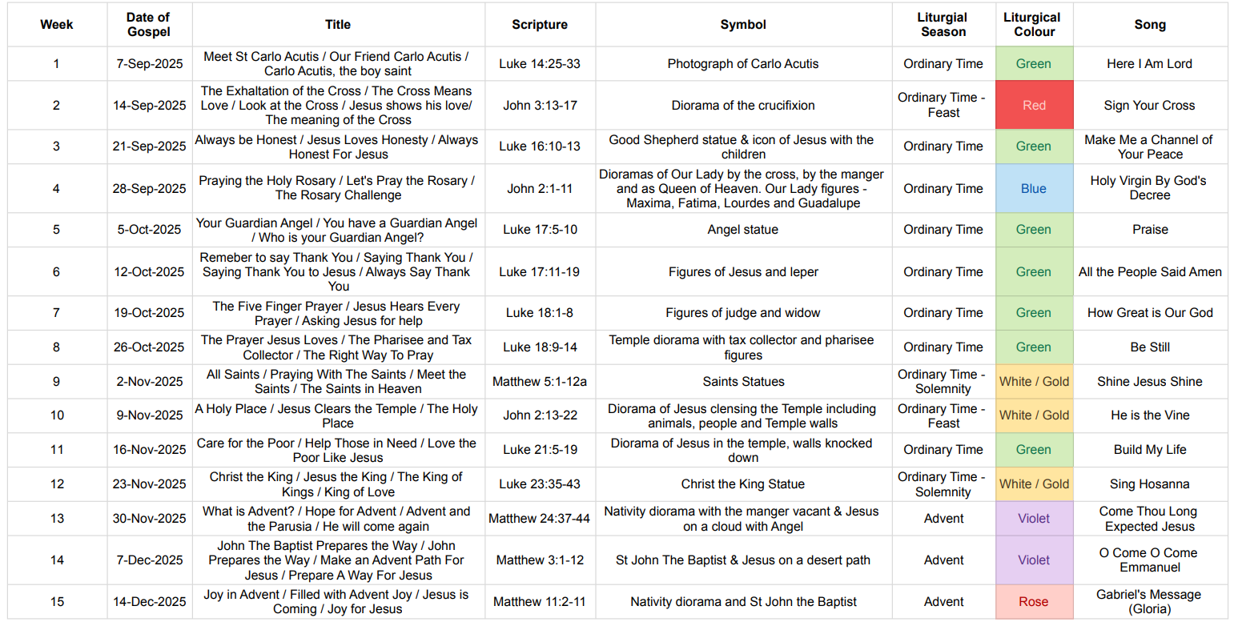

EYFS & KS1 WEEKLY OVERVIEW & WONDER QUESTIONS

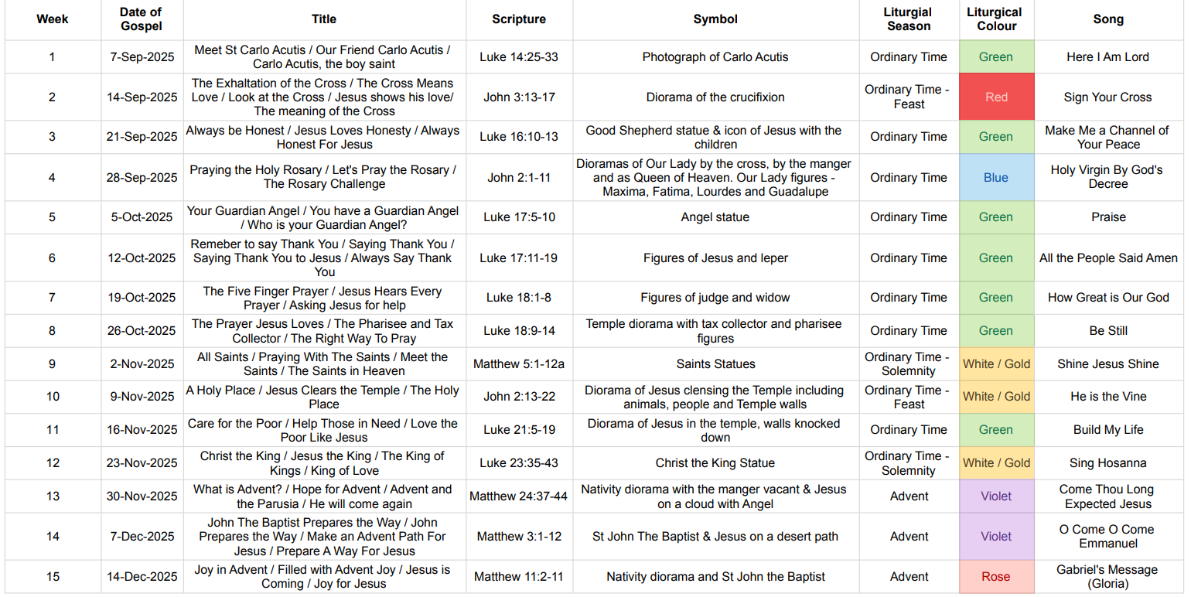

KS2 WEEKLY OVERVIEW & WONDER QUESTIONS

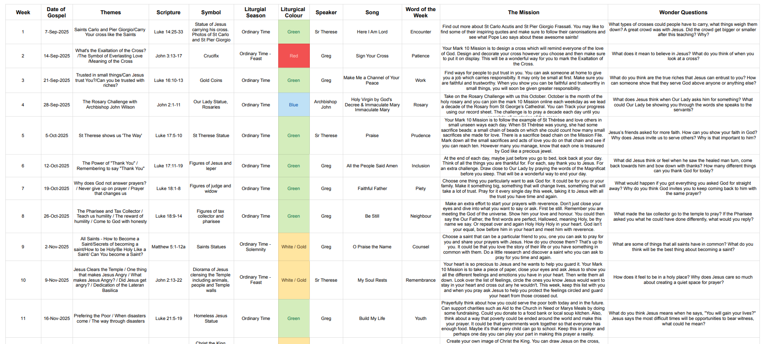

STAGE 2 Annual Plan of Provision
EYFS
PRAYER
Provision | Sacred Space/Use of the senses | Words/Gestures | Prayers of the church
Prayer Bags EYFS and Key Stage 1 have prayer bags that children take in turns to take home for a few days. The prayer bag contains: a bible, a piece of fabric (Liturgical colour), a prayer book which children/parents can write in and then share with the class during prayer time. Other age appropriate artefacts are included for example: shell, candle, rosary beads, cross. There are also special Advent prayer bags that are purple and contain a small stable, the nativity figures and a copy of the Christmas story.
Adult Led | • Give the children access to a choice of the liturgical colour cloths and invite them, with support, to choose the correct one for the liturgical season. Invite them to explain their choice.  • Give them a choice of a selection of candles, crucifixes and relevant statues etc. and invite them to make some choices to set up a sacred focus for their prayer.  • Invite them to explain their choices with support.  • Invite them to make choices in how they might be arranged and explain their choices. | Children engage in spontaneous prayer.  They know how to engage in simple prayer, they know that they join their hands when they pray and they know how to make the Sign of the Cross.  They know prayers that they can say from memory. Children will be able to write a sentence saying thank you, sorry or please (mostly about family). | Sign of the Cross  Grace before meals  Grace after meals  Evening prayer

KEY STAGE 1 – YEARS 1 & 2
PRAYER
Provision | Sacred Space/Use of the senses | Words/Gestures | Prayers of the church
Prayer Bags EYFS and Key Stage 1 have prayer bags that children take in turns to take home for a few days. The prayer bag contains: a bible, a piece of fabric (Liturgical colour), a prayer book which children/parents can write in and then share with the class during prayer time. Other age appropriate artefacts are included for example: shell, candle, rosary beads, cross. There are also special Advent prayer bags that are purple and contain a small stable, the nativity figures and a copy of the Christmas story.
Adult directed | •Give the children access to a choice of the liturgical colour cloths and invite them, with support, to choose the correct one for the liturgical season. Invite them to explain their choice.  • Give them a choice of a selection of candles, crucifixes and relevant statues etc. and invite them to make some choices to set up a sacred focus for their prayer.  • Invite them to explain their choices with support.  • Invite them to make choices in how they might be arranged and explain their choices.  Give the children a wider choice of things that could aid them in deepening their prayer engagements e.g. sacred artwork, relevant songs or music choices to aid reflection linked to the liturgical season.  • Use of a senses box for them to choose things from – e.g. relevant art, statures, sacramentals, godly play objects – ensure the choices are appropriate for the liturgical season and rotated and updated often  • Invite them to choose objects to hold to focus their hearts and minds when praying – e.g. holding cross or prayer pebble.  • Invite them to explain their choices.  • Invite them to reflect on how these things helped them after prayer. | •Using sentence starters to guide them – invite them to spontaneous prayer e.g. ‘I thank God for …’ inviting them to finish the prayer with individual responses  • Begin to give them opportunities to make up and say or write their own spontaneous prayers.  • Invite them to choose and share prayers from appropriate prayer books.  Invite them to include more religious language and show reference to other prayers that they may know  Invite the children to make the sign of the cross to mark the beginning and end of prayer. • Invite children to lead others in making the Sign of the Cross.  • Invite them to be still and silent for short periods of time – inviting them to explain the role that stillness and listening plays in prayer. • Invite them to place their hands in a prayerful way – modelling – to mark that they are lifting hearts and minds to God.  • Invite them to think about and suggest ways that they might like to be (standing, kneeling, sitting etc) to help them to focus on God.  • Invite them to reflect on how these actions and gestures helped them to lift their hearts and minds to God | The Lord’s Prayer  Hail Mary  Glory Be

LOWER KEY STAGE 2 – YEARS 3 & 4
Provision | Sacred Space/Use of the senses | Words/Gestures | Prayers of the church
Child-led (with adult support in planning and delivery) Children start to compose prayers using sentences to form verses. Prayer should start to contain sacramental language – Baptism, Reconciliation, Eucharist, Forgiveness. | As the children develop in their prayer lives, begin to give them more choices and time to plan leading prayer.  • Model and support them in making choices of how to prepare spaces for prayer  • Encourage them to think about creating a prayerful atmosphere including where to pray, prayer focus display or power points, links to liturgical season, making the space different from class time. Model for the children how to make successful choices of aids to prayer  • Model and teach children to plan and lead times of prayer for the class making choices of artwork, music or artefacts – from an appropriate pre-selected range - to help the children to focus their hearts on God.  • Invite the children to begin to reflect on the success of their choices. | •As the children grow in confidence in prayer, give them opportunities to choose the prayer they want to plan and lead.  • Give them choices from traditional prayers of the church  • Invite them to begin to lead their own pre-written prayers – written with guidance and linked to liturgical season  • Give them choices from prayer books  • Support them in beginning to invite petitions from class and wider school. | The Apostles Creed  Act of Contrition  Angel of God  Come, Holy Spirit  Prayer of St Richard of Chichester

UPPER KEY STAGE 2 – YEARS 5 & 6
Provision | Sacred Space/Use of the senses | Words/Gestures | Prayers of the church
Child-led ( minimal adult support) | •As the children enter upper Key Stage 2, they should be given daily opportunities to develop their own prayer lives and have frequent opportunities for prayer.  • Children should be given regular opportunities to plan and lead prayer – in pairs, groups, class and whole school settings.  • They should be given opportunities to plan prayer opportunities and prepare the space in various settings using a variety of different aids to support prayer – art, music, film, drama, sacred objects and be able to explain and evaluate their choices | • Children given the opportunity to plan and lead a variety of different prayer traditions  • Write and lead their own prayers - researching and writing prayers for the world linked to current events and needs of the wider school community  • Plan prayer experiences including but not limited to: o Leading litanies  Leading the rosary o Planning and writing Visio Divina o Planning and leading Lectio Divina o Saying spontaneous prayers of praise, thanks, petition and remorse  n planning prayer, children should consider how the gestures and postures they use when leading prayer can help them and other children to lift their hearts and minds to God. • Children should plan in choices of whether to sit, stand or kneel at times of prayer  • Planned prayer should include extended moments of silence to aid prayerful reflection • Children should reflect on their prayer – possibly using prayer journals - to reflect on their prayer lives.  • Children should be given opportunities to reflect on their planned prayers and evaluate success of choices to aid and support the prayer of others | Morning Offering  The Magnificat  The Rosary  Act of Faith  Act of Hope  Act of Love

CELEBRATION OF THE WORD – PROGRESSION DOCUMENT
- Celebrations of the Word are rooted in scripture and the life of Christ.
- Children grow in independence by gradually moving from participation to contribution to leadership and ultimately leadership.
- Progression ensures children are well prepared to design, lead and reflect on prayerful experiences.
Year | Focus | Role of pupils | Role of Adults | Pupil Outcomes
EYFS | Encountering | Pupils join in with simple prayers, gestures, and songs. | Adults fully plan and lead. Pupils invited to choose symbols (e.g. a candle, cross, seasonal items). | Listening, joining responses, awareness of sacred space  Children can ask and respond to simple questions during Celebration of the Word.  Children will be asked to provide their ideas to contribute towards a class Celebration of the Word using the class prayer box. Children develop their understanding of the liturgical year by celebrating key events in the Church’s calendar.
YEAR 1 | Exploring | Pupils suggest simple prayers or songs. Help place symbols on prayer table. | Adults guide theme, scripture, and structure. | Children will begin to recognise the elements of ‘Gather, Word, Respond, Mission in Celebration of the Word and be able to give some creative ideas for these sections, with support from an adult, using the planning cards and prayer box. They are beginning to show liturgical awareness by being able to talk about celebrating some key events in the liturgical year (e.g. Christmas and Easter).
YEAR 2 | Beginning to contribute | Pupils begin to read short prayers or lines from scripture. Help choose hymns, artefacts. | Adults still structure worship but allow pupil contributions.  Adults lead evaluation of worship but encourage pupil contributions | Children will recognise the elements of ‘Gather, Word, Respond, Mission’ in Celebration of the Word. They give some creative ideas for these sections, with increasing independence using the planning cards and prayer box. During Celebration of the Word, they may answer questions. They show a basic awareness of the liturgical year, understanding that different coloured cloth is used at different times.
CLASS 3 | Guided Planning | Small groups help plan one element (Gather/Listen/Respond /Go Forth). Begin to suggest scripture passages with guidance | Adults provide scripture options and planning templates  Adults provide evaluation questions and small groups evaluate with adult. | Children can recognise the elements of ‘Gather, Word, Respond, Mission’ in Celebration of the Word. They will be able to plan creative ideas for these sections, with less support using the planning cards and prayer box. During Celebration of the Word, they will ask and answer questions. Their planning shows developing liturgical sensitivity e.g. by choosing the correct colour liturgical cloth and relevant religious artefacts, etc
CLASS 4 | Shared Leadership | Pupils plan worship in pairs/small groups using a scaffolded template. They begin leading readings, bidding prayers, music. | Adults act as facilitators and model reflection questions.  Adult and small group of pupils work together to choose evaluation questions. Pupils to evaluate. | Children fully understand the elements of ‘Gather, Word, Respond, Mission’ in Celebration of the Word. They are able to plan creative ideas for these sections using the planning cards as prompts and adapting these to fit in with the theme. They select appropriate artefacts from the prayer box. During Celebration of the Word, children are able to ask and answer questions linked to the theme. Adults will also help elaborate upon sections (e.g. discussion in response to scripture) during delivery. Pupils will demonstrate secure liturgical awareness by selecting fitting resources, such as the correct colour liturgical cloth, or will be proactive in seeking support with this.
CLASS 5 | Independent planning (with guidance as appropriate) | Pupils plan whole worships in groups: select scripture (if not the weekly Gospel), music, prayers, symbols. They lead classmates in prayerful experience | Adults provide feedback, ensure theological accuracy, and support with sensitive issues.  Adult supports children in understanding fully the scripture used in Celebration of the Word.  Adult works with small pupil groups to evaluate worship. Pupils select evaluation questions and reflect on worship independently. | Children will be able to work creatively as a small group to plan and deliver a Celebration of the Word or liturgy independently, with minimal adult support regarding selection of theme and scripture. They will demonstrate secure liturgical awareness through their choice of supporting resources (e.g. liturgical cloth and artefacts) and will be increasingly resourceful and creative in their choices (e.g. by asking for/making items not provided). Children should be able to justify choices of activities by linking these to their chosen scripture. Minimal adult support should be needed during delivery, although adults may interject to extend discussion.
GIFT TEAM | Independent Planning (with guidance) | Pupils independently design and lead Celebrations of the Word for the whole school. They invite participation, create prayers, and lead reflection. | Adults oversee for safeguarding/doctrinal guidance but step back.  Adult supports children in understanding scripture and what this means for their lives today. | Children will be able to plan and deliver creative liturgy and other worship opportunities independently, including selection of a liturgically relevant theme and scripture. Their choice of supporting resources and artefacts will show creativity and resourcefulness, underpinned by secure liturgical awareness. They will be able to justify their planning and choice of activities by linking these to their chosen scripture – and make this explicit during delivery

STAGE 3 Annual Plan of Provision: Pupil Ministries

GIFT TEAM
Roles & responsibilities:
- Consists of 12 pupils (6 x Year 5 pupils, 6 x Year 6 Pupils)
- Nurturing Prayer and Worship within the school community.
- To lead the gathering procession in Celebration of the Word.
- To plan/prepare/support whole school and class Celebrations of the Word
- Support the provision of sacred spaces: Help create and maintain sacred spaces throughout the school including liturgical displays.
- Role Models: To lead pupils being a visible role model of faith demonstrating the Gospel Values which are the epicentre of our school community.

CARITAS AMBASSADORS
Roles & responsibilities:
- Pupils from Year 2 to Year 5
- Working together to support the most vulnerable both locally and globally, promoting the Catholic value of Caritas (love in action).
- Organising Charitable Actions: Lead and coordinate fundraising events or collections for charity such as food bank appeals, mission appeals
- To be leaders of kindness: Promoting the love and kindness of Jesus in our actions. Putting the catholic faith into action!

LAUDATO SI AMBASSADORS
Roles & responsibilities:
- Pupils from Year 3 to Year 6
- Sharing the message of Pope Francis: To recognise the urgent need to protect the environment and live sustainably.
- Planning activities that promote sustainability, encourage waste reduction, and educate their peers about the importance of looking after God’s wonderful world.
- Educating others, nurturing a culture of respect and care throughout the school community.

READING AMBASSADORS
Roles & responsibilities:

MATHS CHAMPIONS
Roles & responsibilities:
